November 22nd, 2020

Baltzi Sofia

Aueb

Pandemic illustrated

Assignment 1 for Data Visualization and Communication

# Introduction

A novel coronavirus, later named Covid-19, was detected in Wuhan, China in 2019. By November of 2020, 218 Countries and Territories around the world had reported to have confirmed cases of the virus.

Using data from the Open Data Portal of European Union, we will attempt to visualize the worldwide spread of the virus, as well as emphasize on how the virus affected the country of Greece.

# Worldwide Spread

In Figure 1, blue line represents the daily total number of cases, summed up for all countries, reported as thousands. Red line represents the daily total number of deaths, also summed up for all countries, but reported as hundreds.

Regarding the cases’ line, we see that it first peaks on February, when Covid-19 started spreading in Wuhan. This peak is followed by near to zero cases for the start of March, but from middle of March and later, cases follow an - overall - increasing trend. On the other hand, the deaths’ curve is relatively stable after the initial increase on mid-April but showing an increase after November.

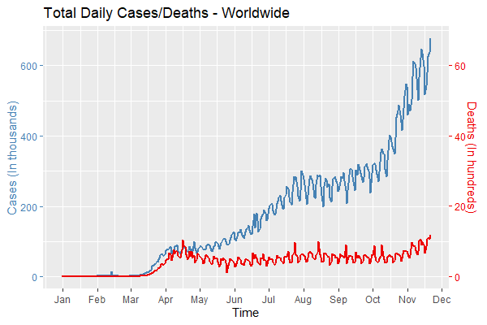

Figure 1

In Figure 2, each line represents the daily total cases per continent. The number of cases was normalized as the percentage of each continents’ population, in order to depict a fair comparison.

By observing Figure 2 we can see that the first peak on cases on February was caused, indeed, by cases in Asia. The large number of cases after October comes mostly from cases in Europe (purple line) and America (blue line). Other continents remain relatively low on cases, but we should not forget that this could probably be due to limited access to Covid-19 tests.

Similarly, in Figure 3, each line represents the daily total deaths per continent, normalized as the percentage of each continents’ population. It is now apparent, that the two peaks we saw on Figure 1 came from the increased number of deaths in Europe the months of April and November. America’s number of deaths is high but mostly steady through the months. Other continents show low numbers.

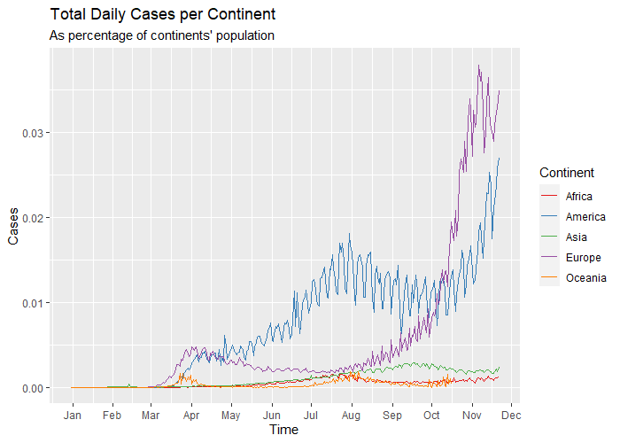

Figure 2

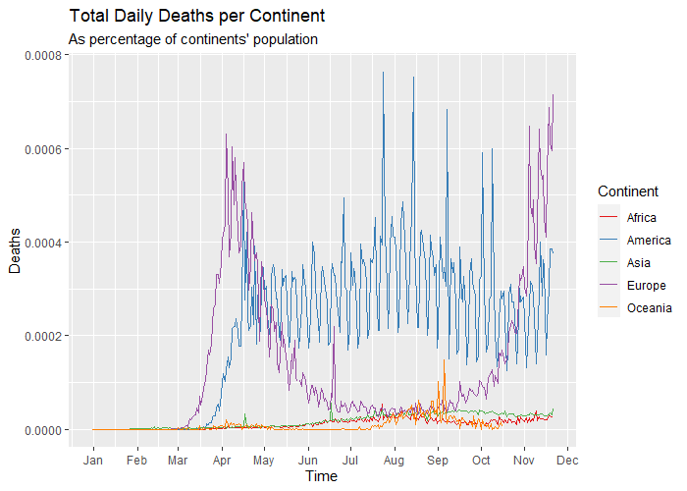

Figure 3

# Europe

In Figure 4, blue bars represent the total cases per month for the continent of Europe, whereas red bars the total deaths. Note that data was available for up to November 21st.

We can see that cases were increased from February to March and from March to April but started decreasing up until July. These we months that European countries had set restrictions to their civilians. Obviously, the summer period, when restrictions became looser and people started traveling more, transmission increased. As expected, deaths follow the same trend as cases – increasing when cases go up and vice versa.

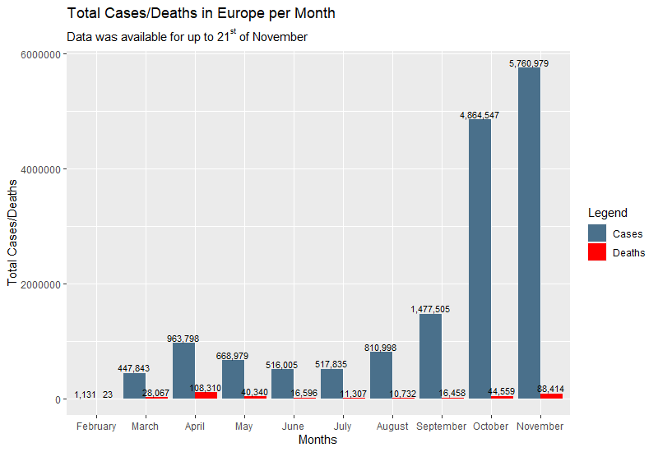

Figure 4

That was a look to the overall period. Figure 5 examines the situation the past month, from 22nd of October to 21st of November.

In this figure, we see a map of Europe, were countries are colored according to the percentage of their population that got infected with Covid-19 the past 30 days. Countries with small infection percentage are colored blue, and those with large are colored red.

From the map we can see that problem is more acute in the countries of Central Europe. Northern Europe stays lower on cases. There, weather is getting colder as winter progresses and thus, people are out less, decreasing the probability of transmitting the virus. Greece, as well as the other Balkan countries, stand low.

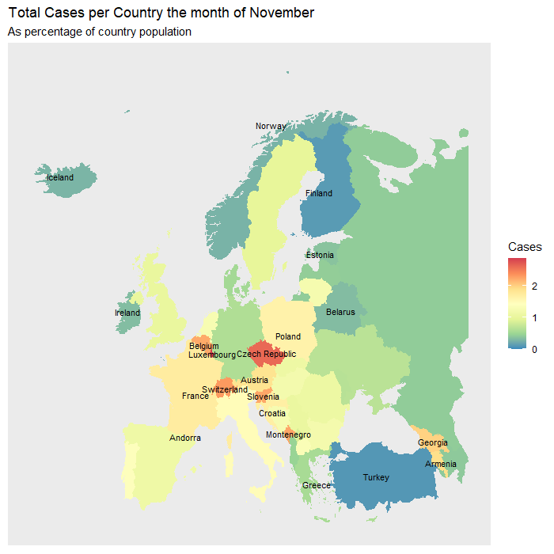

Figure 5

# Greece

Regarding Greece, the first case was detected on February 27th, although there were cases in Europe since late January. Let’s see where Greece stands among the rest countries of European Union.

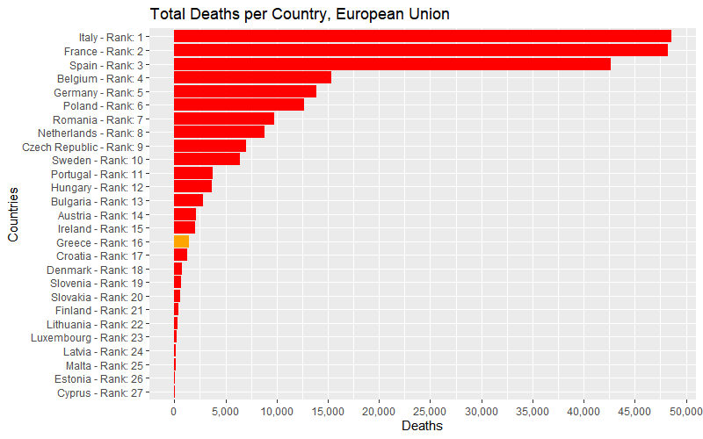Figure 6 and 7 show the ranking of Greece regarding total cases and deaths, since pandemic outburst, respectively. There are not many variations among ranking in the two diagrams and Greece is mid-low in both.

Figure 7

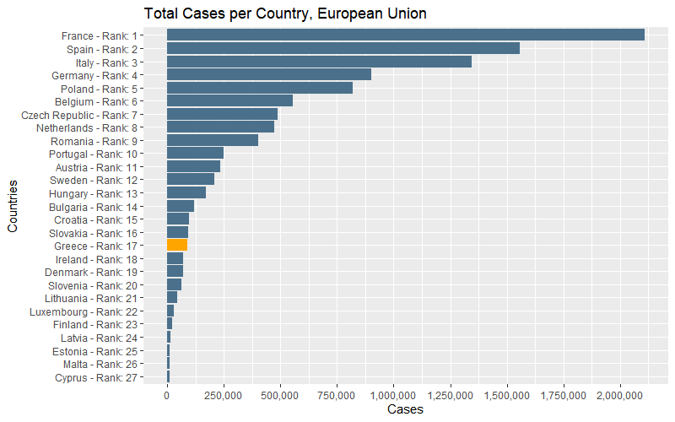

Figure 6

For a more detailed view, let’s observe the next figures. In Figures 8 (and 9), green line represents Europe’s – whole Europe’s, not just European Union’s – cases (deaths) throughout the pandemic, normalized to Europe’s population (neither cases (deaths) nor population include Greece’s figures). Orange line represents the cases (deaths) of Greece, also normalized to population of the country.

In Figure 8 we can see that Greece has generally less cases than the European average. Both Europe and Greece seem to follow the same trend line, showing an increase on March and April, followed by low cases the summer months. This is to be expected since around March all European governments set registrations and/or went to complete lockdowns. From August and onwards cases increased, leading again to lockdowns on autumn months. Although Greece was always bellow Europe, in the beginning of November the European average was reached.

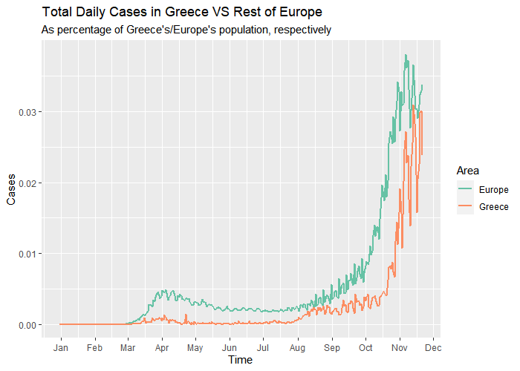

Figure 8

Observing Figure 9, we see that Europe had an intense problem regarding deaths by Covid-19 when it firstly started spreading but the situation was more controlled for Greece. That cannot be said for mid-August and later when Greece’s average was about the same – or even higher at times – as Europe’s.

It is important to note that y-axis scale is different between figures 8 and 9 but both diagrams seem to be peaking around the same time.

In Figure 10, blue bars represent the total cases per month for Greece, whereas red bars the total deaths. Note that data was available for up to November 21st.

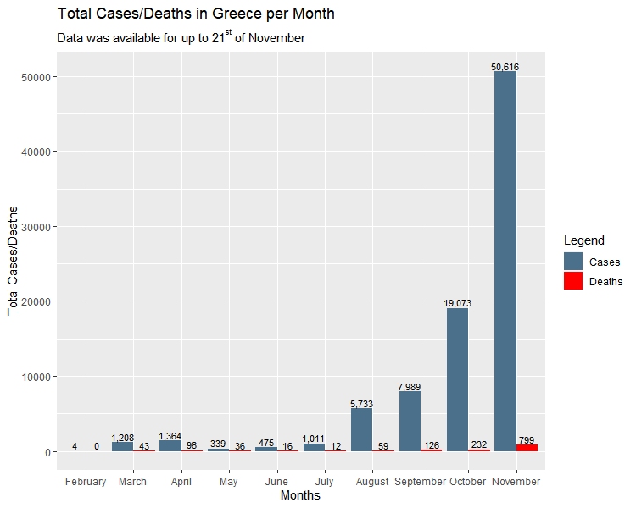

Figure 10

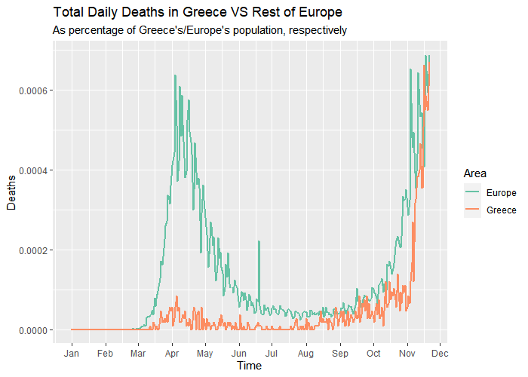

Figure 9

Adding to Figure 10, there are Figures 11 and 12 that show the percentage difference between months for cases and deaths respectively. Formula used for calculation was (“value current month” – “value previous month”)/ “value previous month”. Months shown on x-axis are the “current” months. Since on February there were so few cases (and 0 deaths), the percentage differences of March got very high values and “swallowed” the other values. Therefore, March was left out from diagram.

Regarding the cases, the only month that a reduction is observed is May, the month of lockdown. After that, cases increase slightly from month to month. Between July and August there is a huge increase on cases (almost 5 times up). From there and on there is a constant increase.

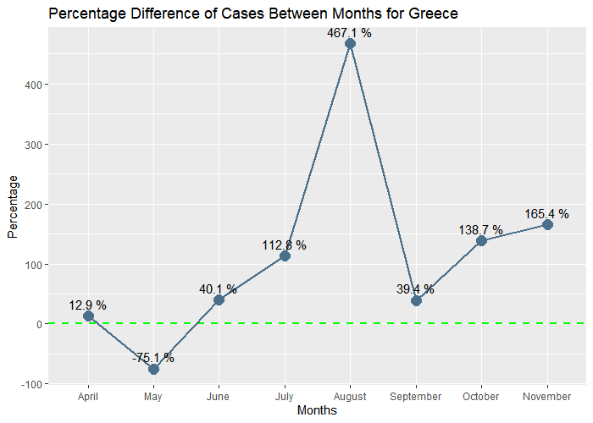

Figure 11

Contrary to cases, deaths continued to decrease until July, but increased on August (4 times up). As an absolute number, there were less deaths on August than on April though. From September and on deaths continue to increase.

# Conclusion

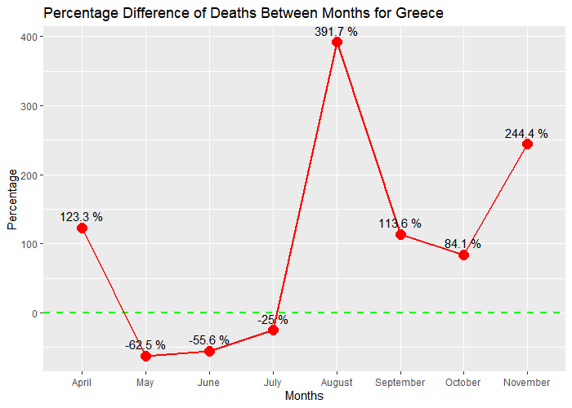

Figure 12

If we had to reach a conclusion for Greece, that would be that the situation seems to be critical, to say the least. Given that day by day the cases as well as the losses of Covid-19 increase, our best chance is to try our best to protect ourselves. Even if we are not in immediate danger of losing our lives, we ought to protect the people we associate with, and those who they associate with and so on.

On a positive note, here’s a useless plot…